**BASE MODEL: Default convolutional** (filters(32), stride(1,1), bias_initializer("zeros"), kernel_size(1,1))

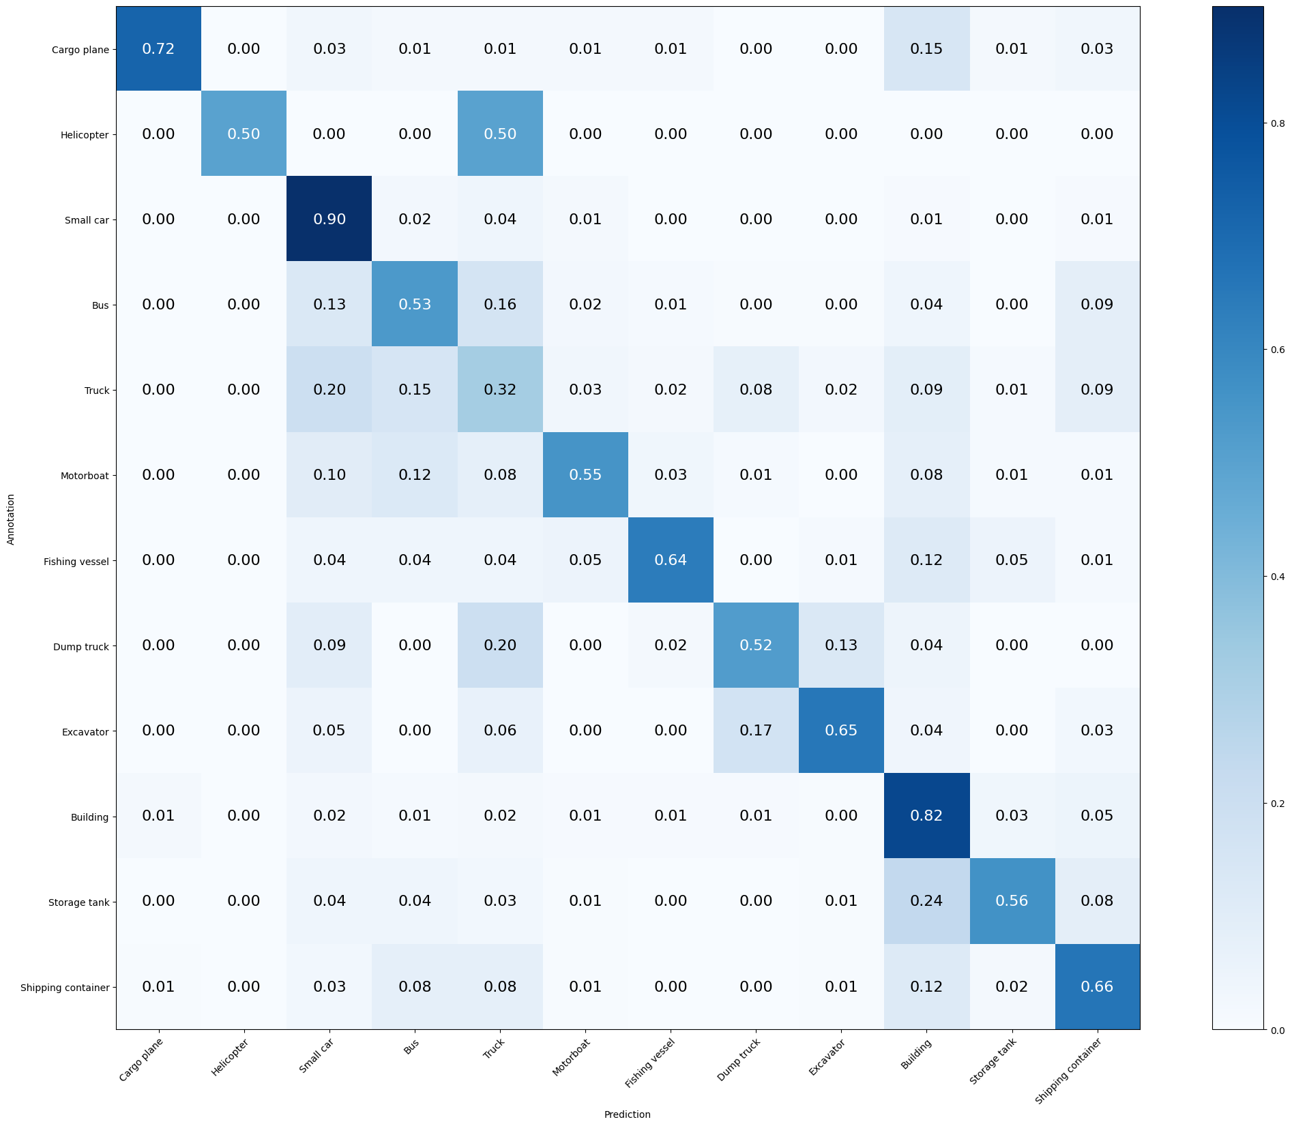

Mean Accuracy: 67.166%

Mean Recall: 61.543%

Mean Precision: 68.663%

> Cargo plane: Recall: 72.059% Precision: 85.965% Specificity: 99.614% Dice: 78.400%

> Helicopter: Recall: 50.000% Precision: 100.000% Specificity: 100.000% Dice: 66.667%

> Small car: Recall: 90.238% Precision: 74.314% Specificity: 92.375% Dice: 81.505%

> Bus: Recall: 53.425% Precision: 57.073% Specificity: 95.414% Dice: 55.189%

> Truck: Recall: 32.075% Precision: 42.079% Specificity: 93.753% Dice: 36.403%

> Motorboat: Recall: 55.056% Precision: 61.250% Specificity: 98.487% Dice: 57.988%

> Fishing vessel: Recall: 63.636% Precision: 72.059% Specificity: 99.078% Dice: 67.586%

> Dump truck: Recall: 52.137% Precision: 61.000% Specificity: 98.070% Dice: 56.221%

> Excavator: Recall: 65.385% Precision: 65.385% Specificity: 98.689% Dice: 65.385%

> Building: Recall: 82.056% Precision: 76.648% Specificity: 92.448% Dice: 79.260%

> Storage tank: Recall: 56.209% Precision: 74.783% Specificity: 98.539% Dice: 64.179%

> Shipping container: Recall: 66.234% Precision: 53.403% Specificity: 95.514% Dice: 59.130%

**MODEL 1: Stride (2,2)**

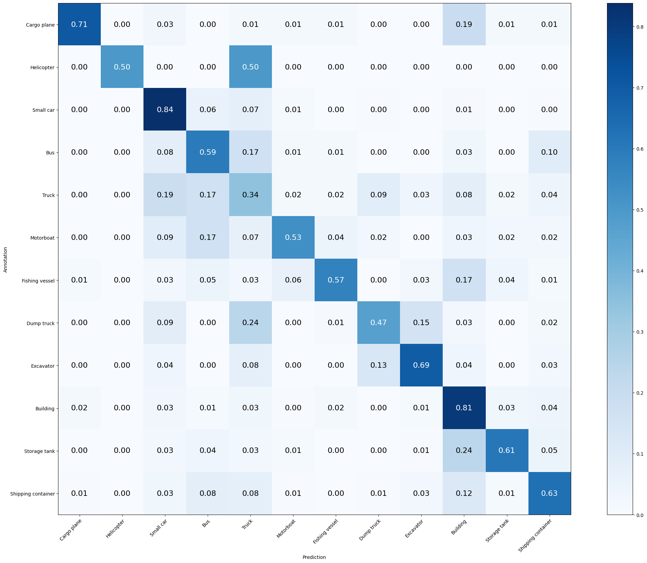

Mean Accuracy: 66.090%

Mean Recall: 60.742%

Mean Precision: 63.479%

> Cargo plane: Recall: 70.588% Precision: 82.759% Specificity: 99.517% Dice: 76.190%

> Helicopter: Recall: 50.000% Precision: 50.000% Specificity: 99.953% Dice: 50.000%

> Small car: Recall: 83.810% Precision: 75.375% Specificity: 93.306% Dice: 79.369%

> Bus: Recall: 59.361% Precision: 53.498% Specificity: 94.112% Dice: 56.277%

> Truck: Recall: 34.340% Precision: 38.889% Specificity: 92.365% Dice: 36.473%

> Motorboat: Recall: 52.809% Precision: 66.197% Specificity: 98.829% Dice: 58.750%

> Fishing vessel: Recall: 57.143% Precision: 66.667% Specificity: 98.933% Dice: 61.538%

> Dump truck: Recall: 47.009% Precision: 57.895% Specificity: 98.021% Dice: 51.887%

> Excavator: Recall: 69.231% Precision: 58.065% Specificity: 98.107% Dice: 63.158%

> Building: Recall: 80.847% Precision: 76.820% Specificity: 92.631% Dice: 78.782%

> Storage tank: Recall: 60.784% Precision: 77.500% Specificity: 98.640% Dice: 68.132%

> Shipping container: Recall: 62.987% Precision: 58.084% Specificity: 96.472% Dice: 60.436%

**MODEL 2: Batch Normalization**

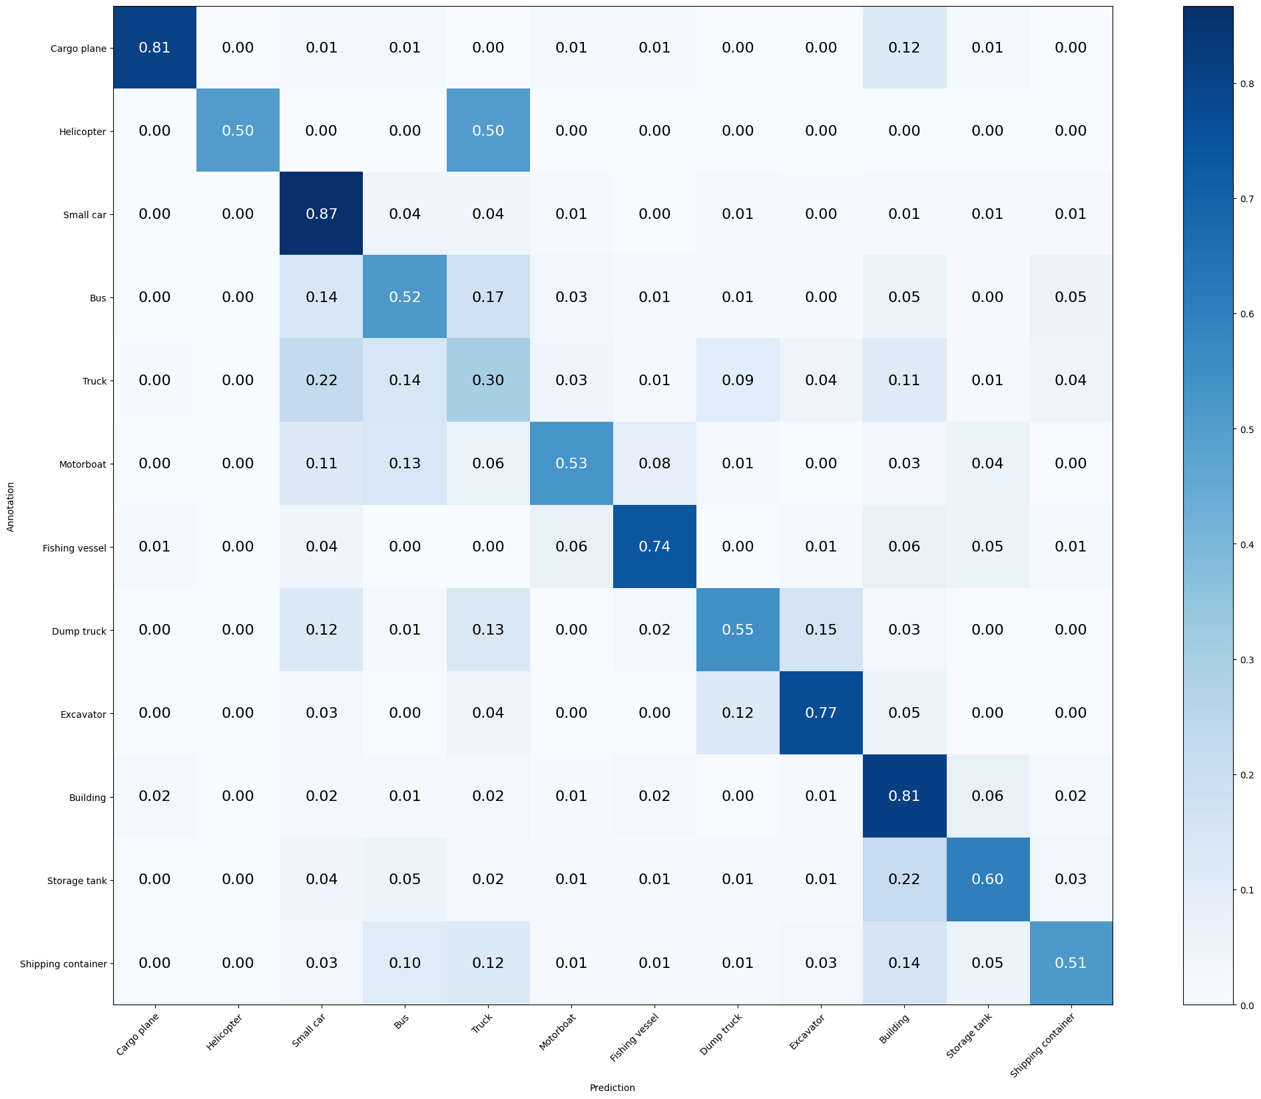

Mean Accuracy: 66.183%

Mean Recall: 62.525%

Mean Precision: 66.828%

> Cargo plane: Recall: 80.882% Precision: 84.615% Specificity: 99.517% Dice: 82.707%

> Helicopter: Recall: 50.000% Precision: 100.000% Specificity: 100.000% Dice: 66.667%

> Small car: Recall: 86.667% Precision: 72.366% Specificity: 91.909% Dice: 78.873%

> Bus: Recall: 51.598% Precision: 53.555% Specificity: 94.893% Dice: 52.558%

> Truck: Recall: 29.811% Precision: 41.361% Specificity: 94.020% Dice: 34.649%

> Motorboat: Recall: 52.809% Precision: 59.494% Specificity: 98.438% Dice: 55.952%

> Fishing vessel: Recall: 74.026% Precision: 67.059% Specificity: 98.641% Dice: 70.370%

> Dump truck: Recall: 54.701% Precision: 58.716% Specificity: 97.773% Dice: 56.637%

> Excavator: Recall: 76.923% Precision: 58.824% Specificity: 97.961% Dice: 66.667%

> Building: Recall: 81.452% Precision: 76.660% Specificity: 92.509% Dice: 78.983%

> Storage tank: Recall: 60.131% Precision: 63.448% Specificity: 97.330% Dice: 61.745%

> Shipping container: Recall: 51.299% Precision: 65.833% Specificity: 97.933% Dice: 57.664%

**MODEL 3: bias_initializer("random_uniform")**

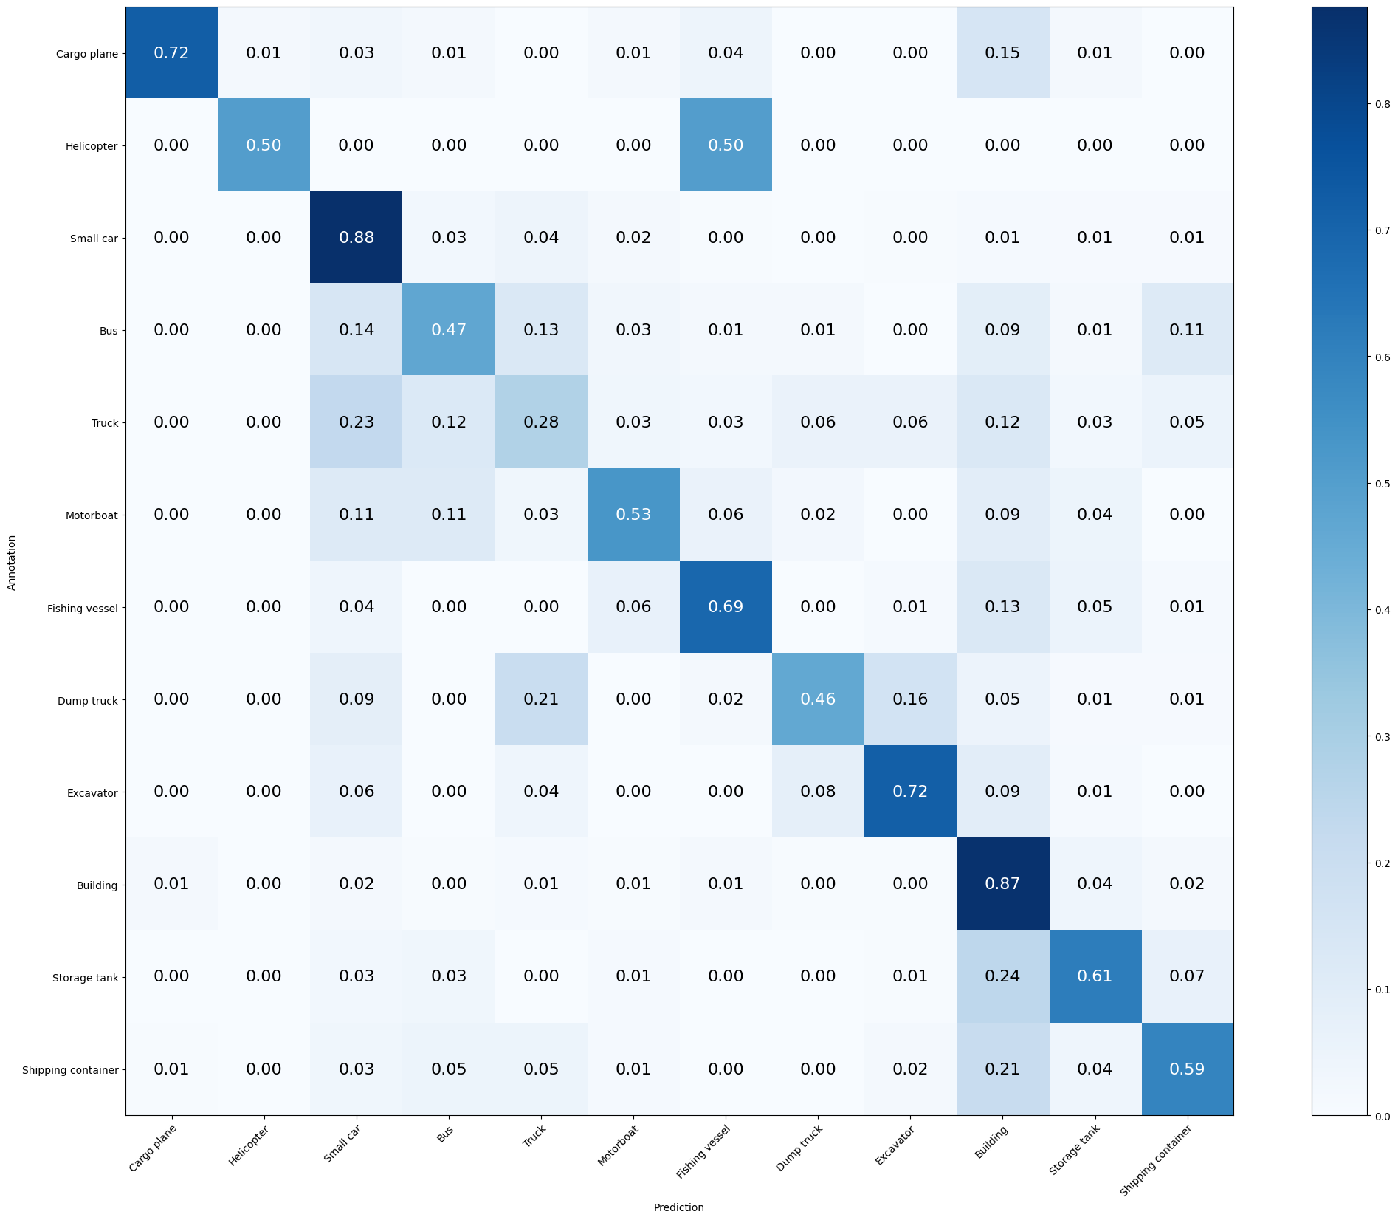

Mean Accuracy: 66.370%

Mean Recall: 60.901%

Mean Precision: 62.854%

> Cargo plane: Recall: 72.059% Precision: 85.965% Specificity: 99.614% Dice: 78.400%

> Helicopter: Recall: 50.000% Precision: 50.000% Specificity: 99.953% Dice: 50.000%

> Small car: Recall: 87.619% Precision: 72.727% Specificity: 91.967% Dice: 79.482%

> Bus: Recall: 46.575% Precision: 60.000% Specificity: 96.456% Dice: 52.442%

> Truck: Recall: 27.547% Precision: 45.062% Specificity: 95.248% Dice: 34.192%

> Motorboat: Recall: 52.809% Precision: 57.317% Specificity: 98.292% Dice: 54.971%

> Fishing vessel: Recall: 68.831% Precision: 63.855% Specificity: 98.544% Dice: 66.250%

> Dump truck: Recall: 46.154% Precision: 65.854% Specificity: 98.615% Dice: 54.271%

> Excavator: Recall: 71.795% Precision: 56.566% Specificity: 97.913% Dice: 63.277%

> Building: Recall: 86.895% Precision: 72.074% Specificity: 89.829% Dice: 78.793%

> Storage tank: Recall: 61.438% Precision: 65.734% Specificity: 97.531% Dice: 63.514%

> Shipping container: Recall: 59.091% Precision: 59.091% Specificity: 96.825% Dice: 59.091%

**MODEL 4: bias_initializer("ones")**

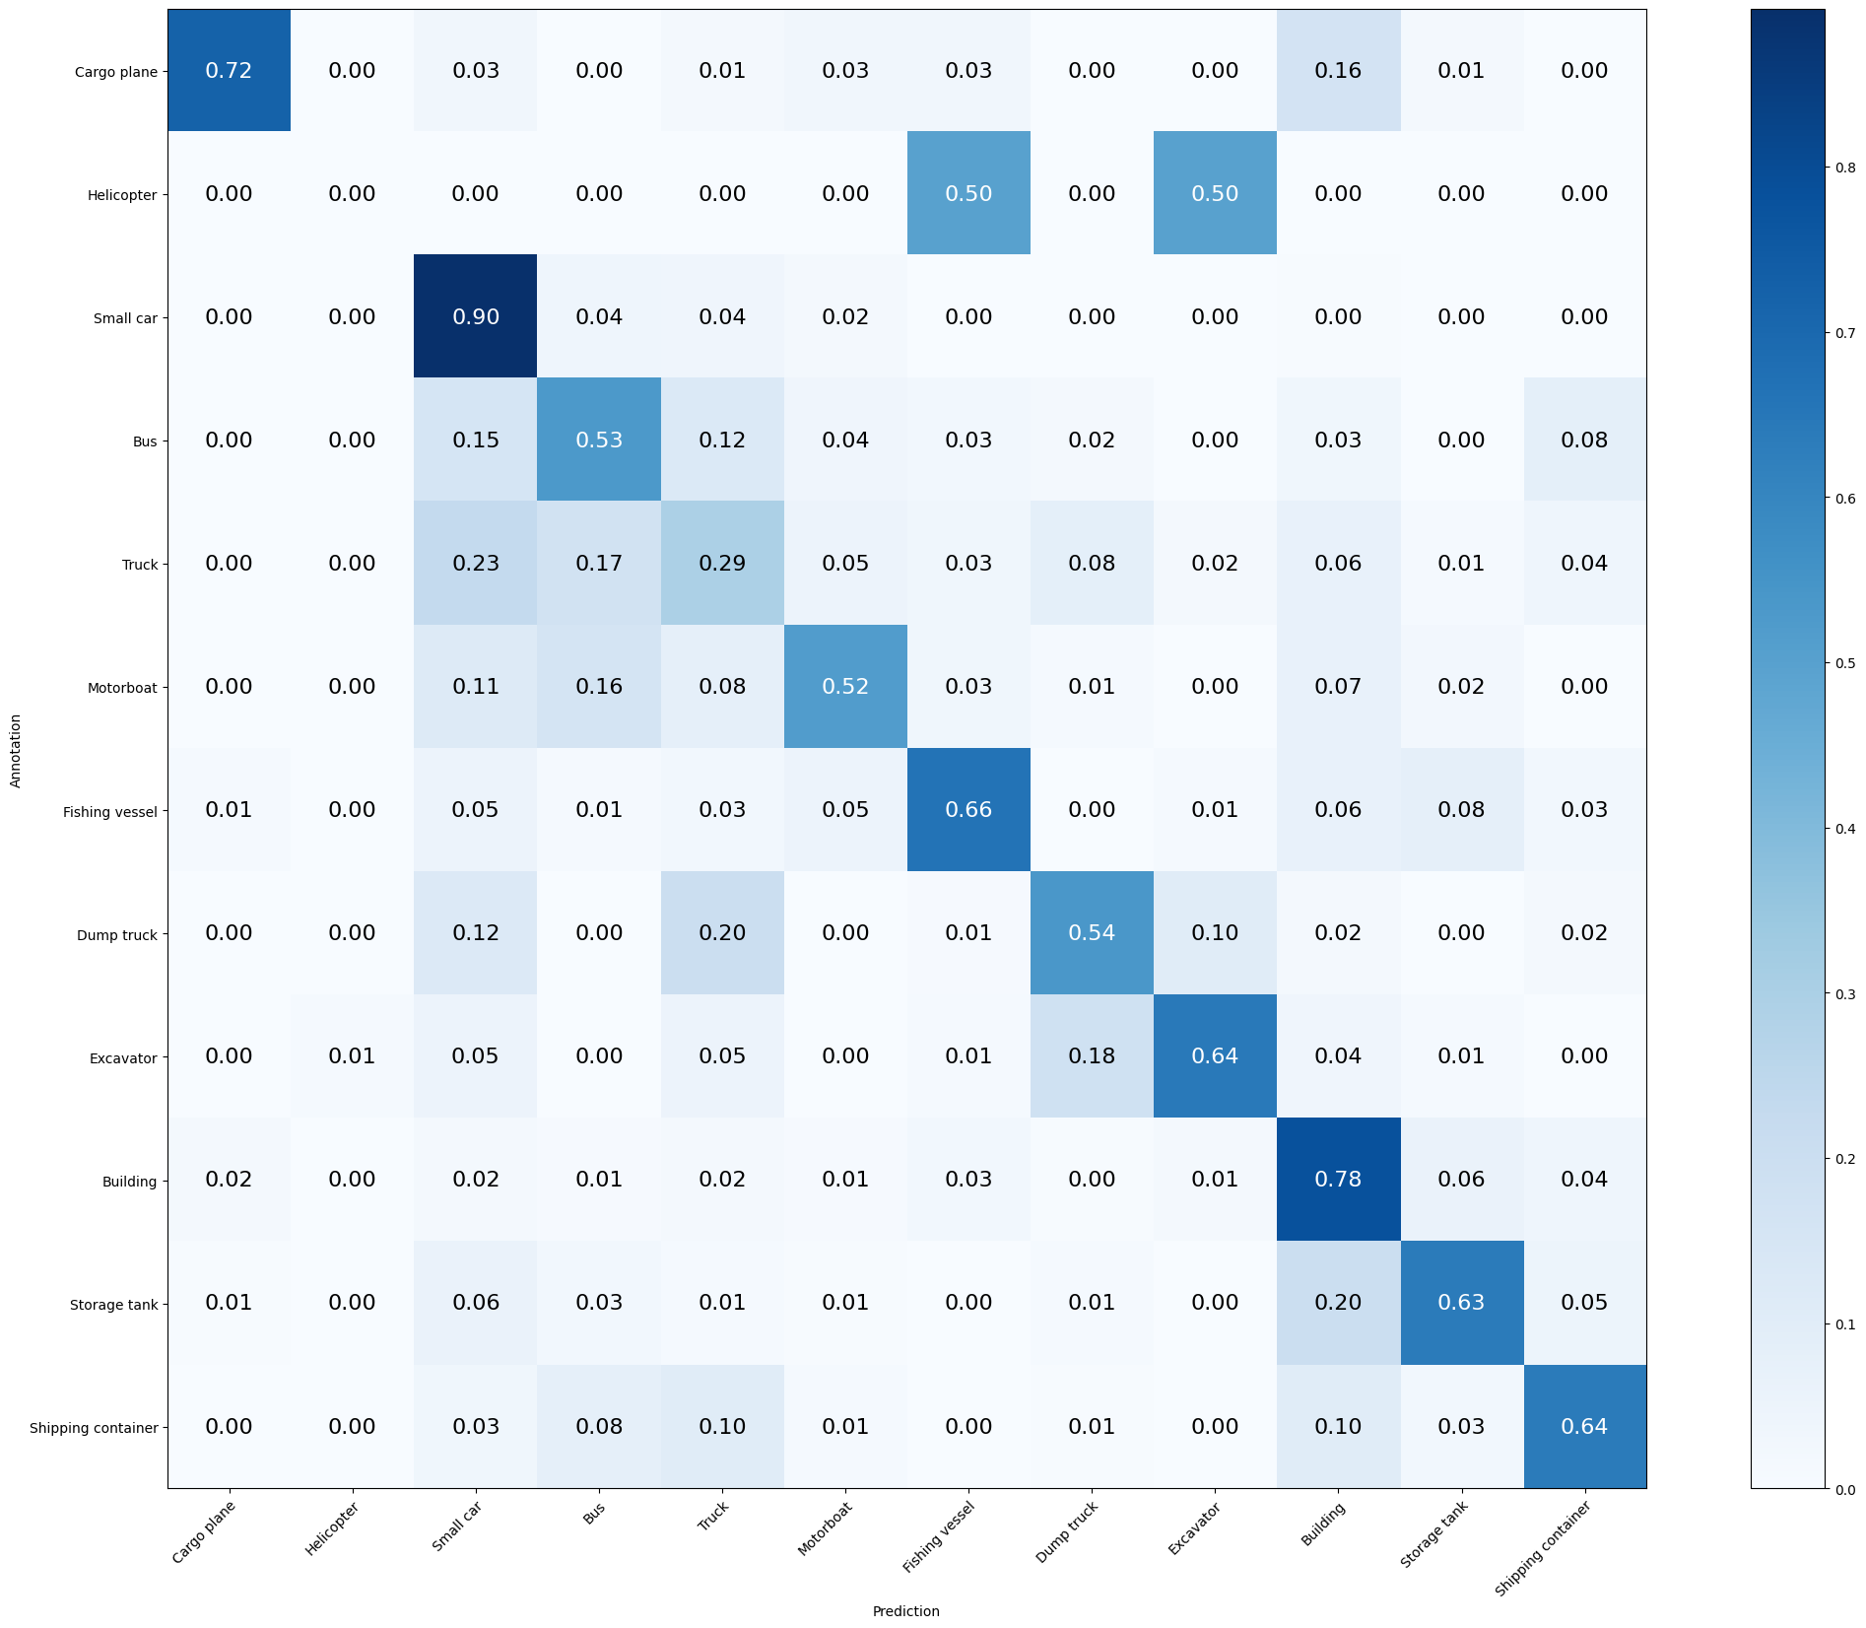

Mean Accuracy: 66.043%

Mean Recall: 57.093%

Mean Precision: 57.809%

> Cargo plane: Recall: 72.059% Precision: 83.051% Specificity: 99.517% Dice: 77.165%

> Helicopter: Recall: 0.000% Precision: 0.000% Specificity: 99.953% Dice: 0.000%

> Small car: Recall: 89.524% Precision: 71.212% Specificity: 91.153% Dice: 79.325%

> Bus: Recall: 52.968% Precision: 53.953% Specificity: 94.841% Dice: 53.456%

> Truck: Recall: 29.434% Precision: 41.935% Specificity: 94.234% Dice: 34.590%

> Motorboat: Recall: 51.685% Precision: 52.874% Specificity: 97.999% Dice: 52.273%

> Fishing vessel: Recall: 66.234% Precision: 57.955% Specificity: 98.205% Dice: 61.818%

> Dump truck: Recall: 53.846% Precision: 57.798% Specificity: 97.724% Dice: 55.752%

> Excavator: Recall: 64.103% Precision: 65.789% Specificity: 98.738% Dice: 64.935%

> Building: Recall: 78.226% Precision: 79.671% Specificity: 93.971% Dice: 78.942%

> Storage tank: Recall: 63.399% Precision: 67.832% Specificity: 97.683% Dice: 65.541%

> Shipping container: Recall: 63.636% Precision: 61.635% Specificity: 96.925% Dice: 62.620%

**MODEL 5: Kernel Size (3,3)**

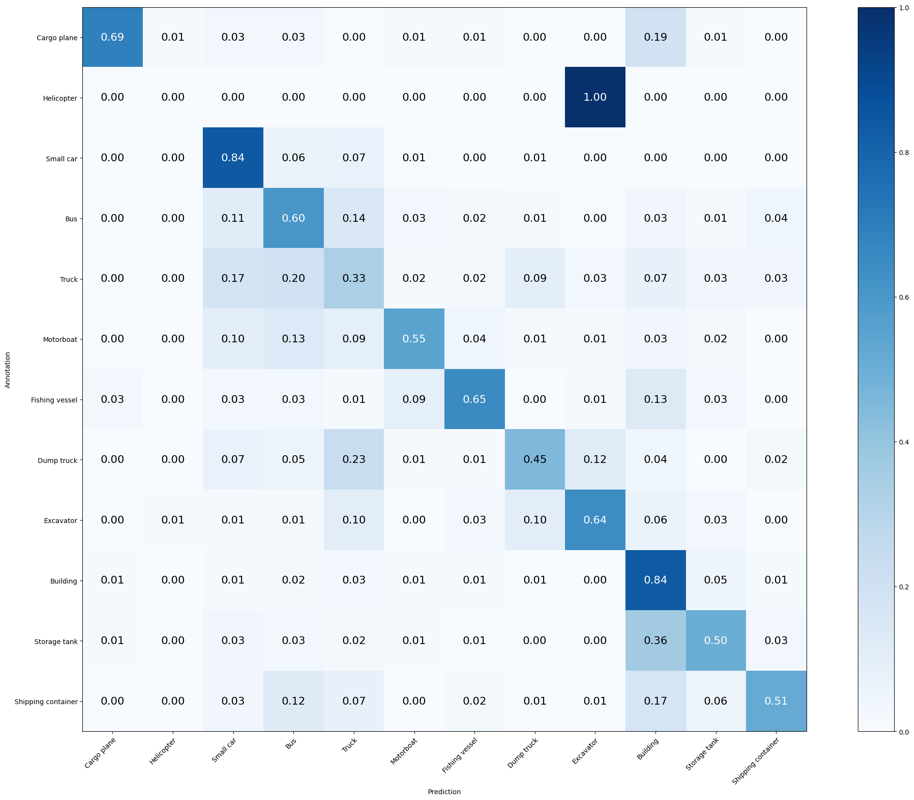

Mean Accuracy: 65.154%

Mean Recall: 55.111%

Mean Precision: 58.131%

> Cargo plane: Recall: 69.118% Precision: 82.456% Specificity: 99.517% Dice: 75.200%

> Helicopter: Recall: 0.000% Precision: 0.000% Specificity: 99.906% Dice: 0.000%

> Small car: Recall: 84.048% Precision: 76.573% Specificity: 93.714% Dice: 80.136%

> Bus: Recall: 60.274% Precision: 49.438% Specificity: 92.965% Dice: 54.321%

> Truck: Recall: 33.208% Precision: 40.183% Specificity: 93.006% Dice: 36.364%

> Motorboat: Recall: 55.056% Precision: 62.821% Specificity: 98.585% Dice: 58.683%

> Fishing vessel: Recall: 64.935% Precision: 63.291% Specificity: 98.593% Dice: 64.103%

> Dump truck: Recall: 45.299% Precision: 55.208% Specificity: 97.872% Dice: 49.765%

> Excavator: Recall: 64.103% Precision: 62.500% Specificity: 98.544% Dice: 63.291%

> Building: Recall: 83.669% Precision: 74.240% Specificity: 91.230% Dice: 78.673%

> Storage tank: Recall: 50.327% Precision: 59.690% Specificity: 97.380% Dice: 54.610%

> Shipping container: Recall: 51.299% Precision: 71.171% Specificity: 98.387% Dice: 59.623%

**MODEL 6: Two Convolutional layers** (*batch_size reduced to 64*)

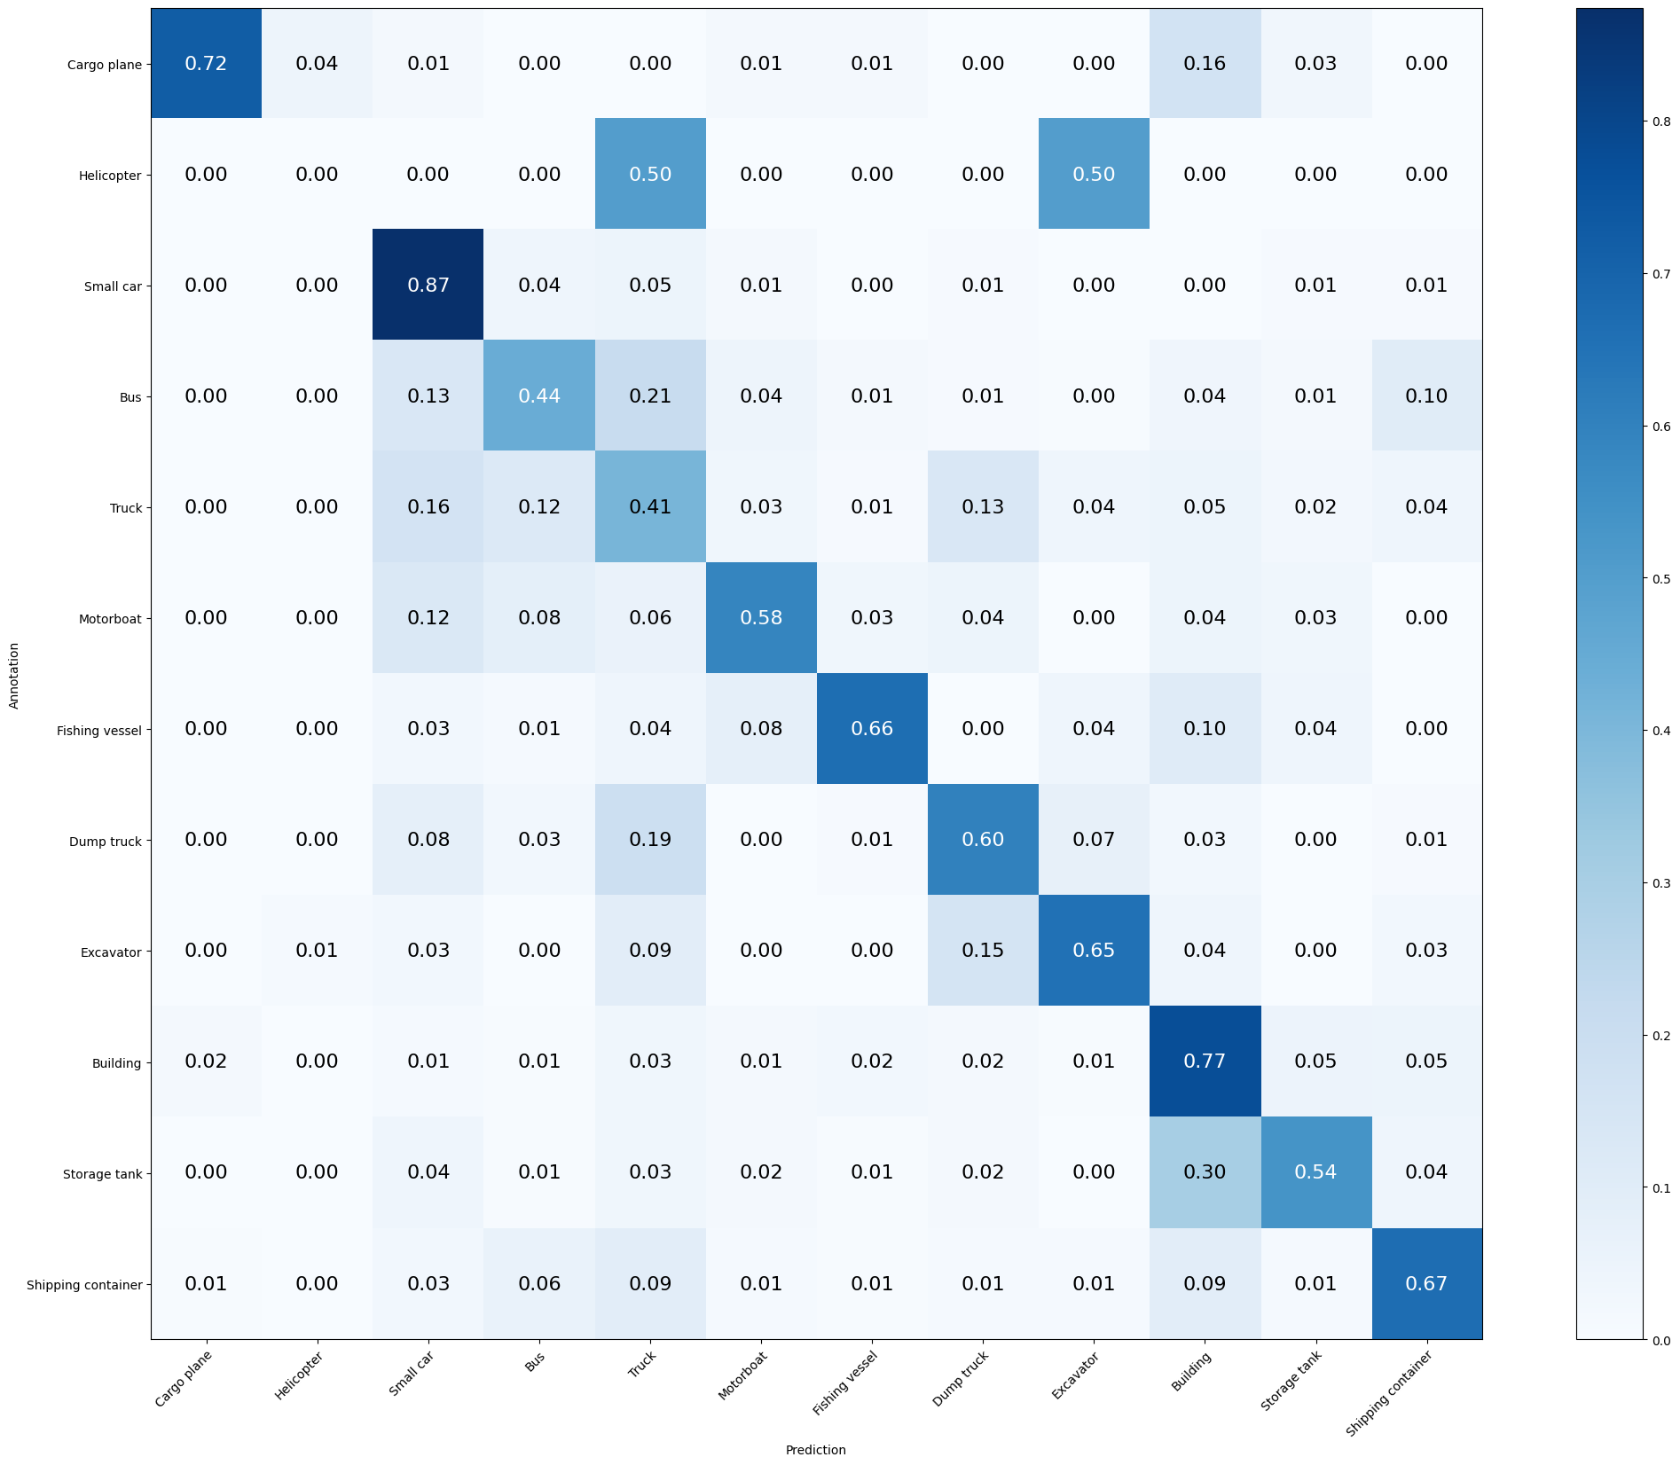

Mean Accuracy: 66.090%

Mean Recall: 57.671%

Mean Precision: 58.293%

> Cargo plane: Recall: 72.059% Precision: 83.051% Specificity: 99.517% Dice: 77.165%

> Helicopter: Recall: 0.000% Precision: 0.000% Specificity: 99.813% Dice: 0.000%

> Small car: Recall: 87.381% Precision: 76.618% Specificity: 93.481% Dice: 81.646%

> Bus: Recall: 44.292% Precision: 57.738% Specificity: 96.300% Dice: 50.129%

> Truck: Recall: 40.755% Precision: 44.082% Specificity: 92.686% Dice: 42.353%

> Motorboat: Recall: 58.427% Precision: 54.737% Specificity: 97.901% Dice: 56.522%

> Fishing vessel: Recall: 66.234% Precision: 67.105% Specificity: 98.787% Dice: 66.667%

> Dump truck: Recall: 59.829% Precision: 49.645% Specificity: 96.487% Dice: 54.264%

> Excavator: Recall: 65.385% Precision: 64.557% Specificity: 98.641% Dice: 64.968%

> Building: Recall: 77.218% Precision: 77.688% Specificity: 93.301% Dice: 77.452%

> Storage tank: Recall: 53.595% Precision: 64.062% Specificity: 97.683% Dice: 58.363%

> Shipping container: Recall: 66.883% Precision: 60.234% Specificity: 96.573% Dice: 63.385%

**MODEL 7: Two Convolutional layers** (*batch_size increased to 128, reduced one FC layer, learning_rate increased to 0.001, early_stopping increased to 20*)

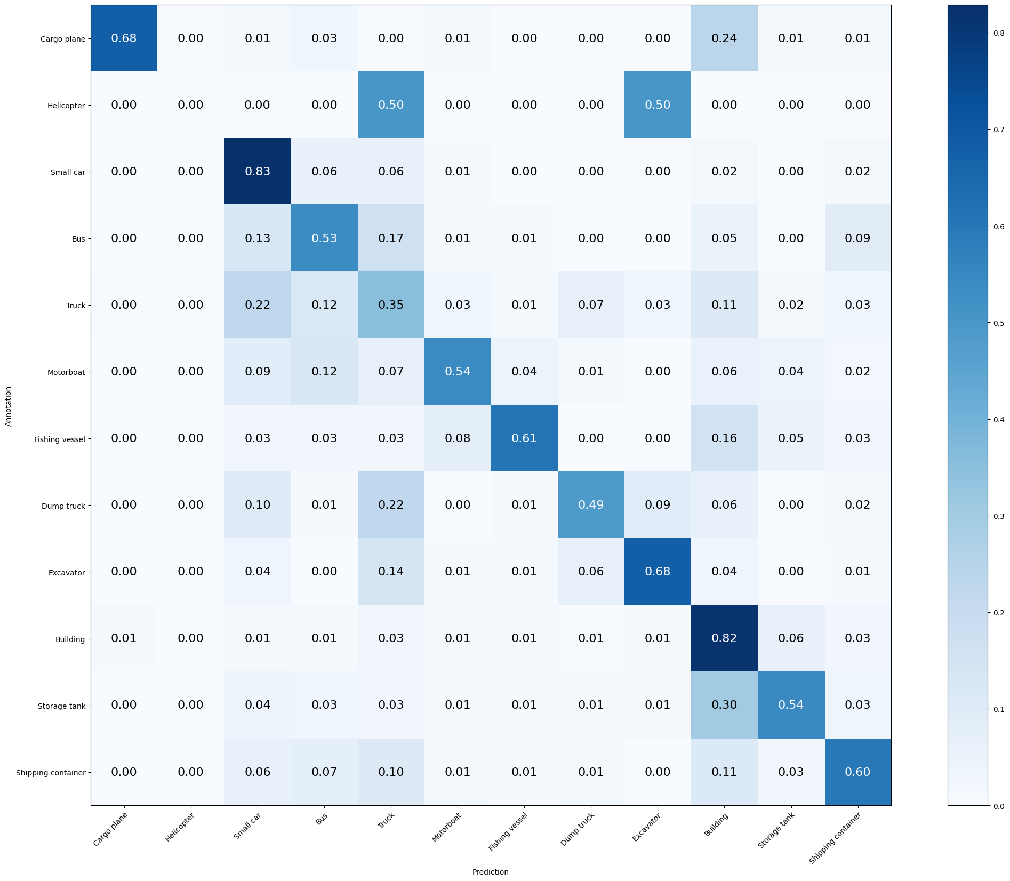

Mean Accuracy: 64.967%

Mean Recall: 55.525%

Mean Precision: 59.450%

> Cargo plane: Recall: 67.647% Precision: 90.196% Specificity: 99.758% Dice: 77.311%

> Helicopter: Recall: 0.000% Precision: 0.000% Specificity: 100.000% Dice: 0.000%

> Small car: Recall: 82.857% Precision: 72.500% Specificity: 92.317% Dice: 77.333%

> Bus: Recall: 53.425% Precision: 55.189% Specificity: 95.050% Dice: 54.292%

> Truck: Recall: 35.094% Precision: 39.574% Specificity: 92.419% Dice: 37.200%

> Motorboat: Recall: 53.933% Precision: 62.338% Specificity: 98.585% Dice: 57.831%

> Fishing vessel: Recall: 61.039% Precision: 70.149% Specificity: 99.030% Dice: 65.278%

> Dump truck: Recall: 48.718% Precision: 64.045% Specificity: 98.417% Dice: 55.340%

> Excavator: Recall: 67.949% Precision: 63.855% Specificity: 98.544% Dice: 65.839%

> Building: Recall: 81.653% Precision: 72.451% Specificity: 90.621% Dice: 76.777%

> Storage tank: Recall: 54.248% Precision: 63.359% Specificity: 97.582% Dice: 58.451%

> Shipping container: Recall: 59.740% Precision: 59.740% Specificity: 96.875% Dice: 59.740%

**MODEL 8: Three Convolutional layers** (*batch_size reduced to 32, kernel_size(3,3), GlobalAveragePooling2D*)

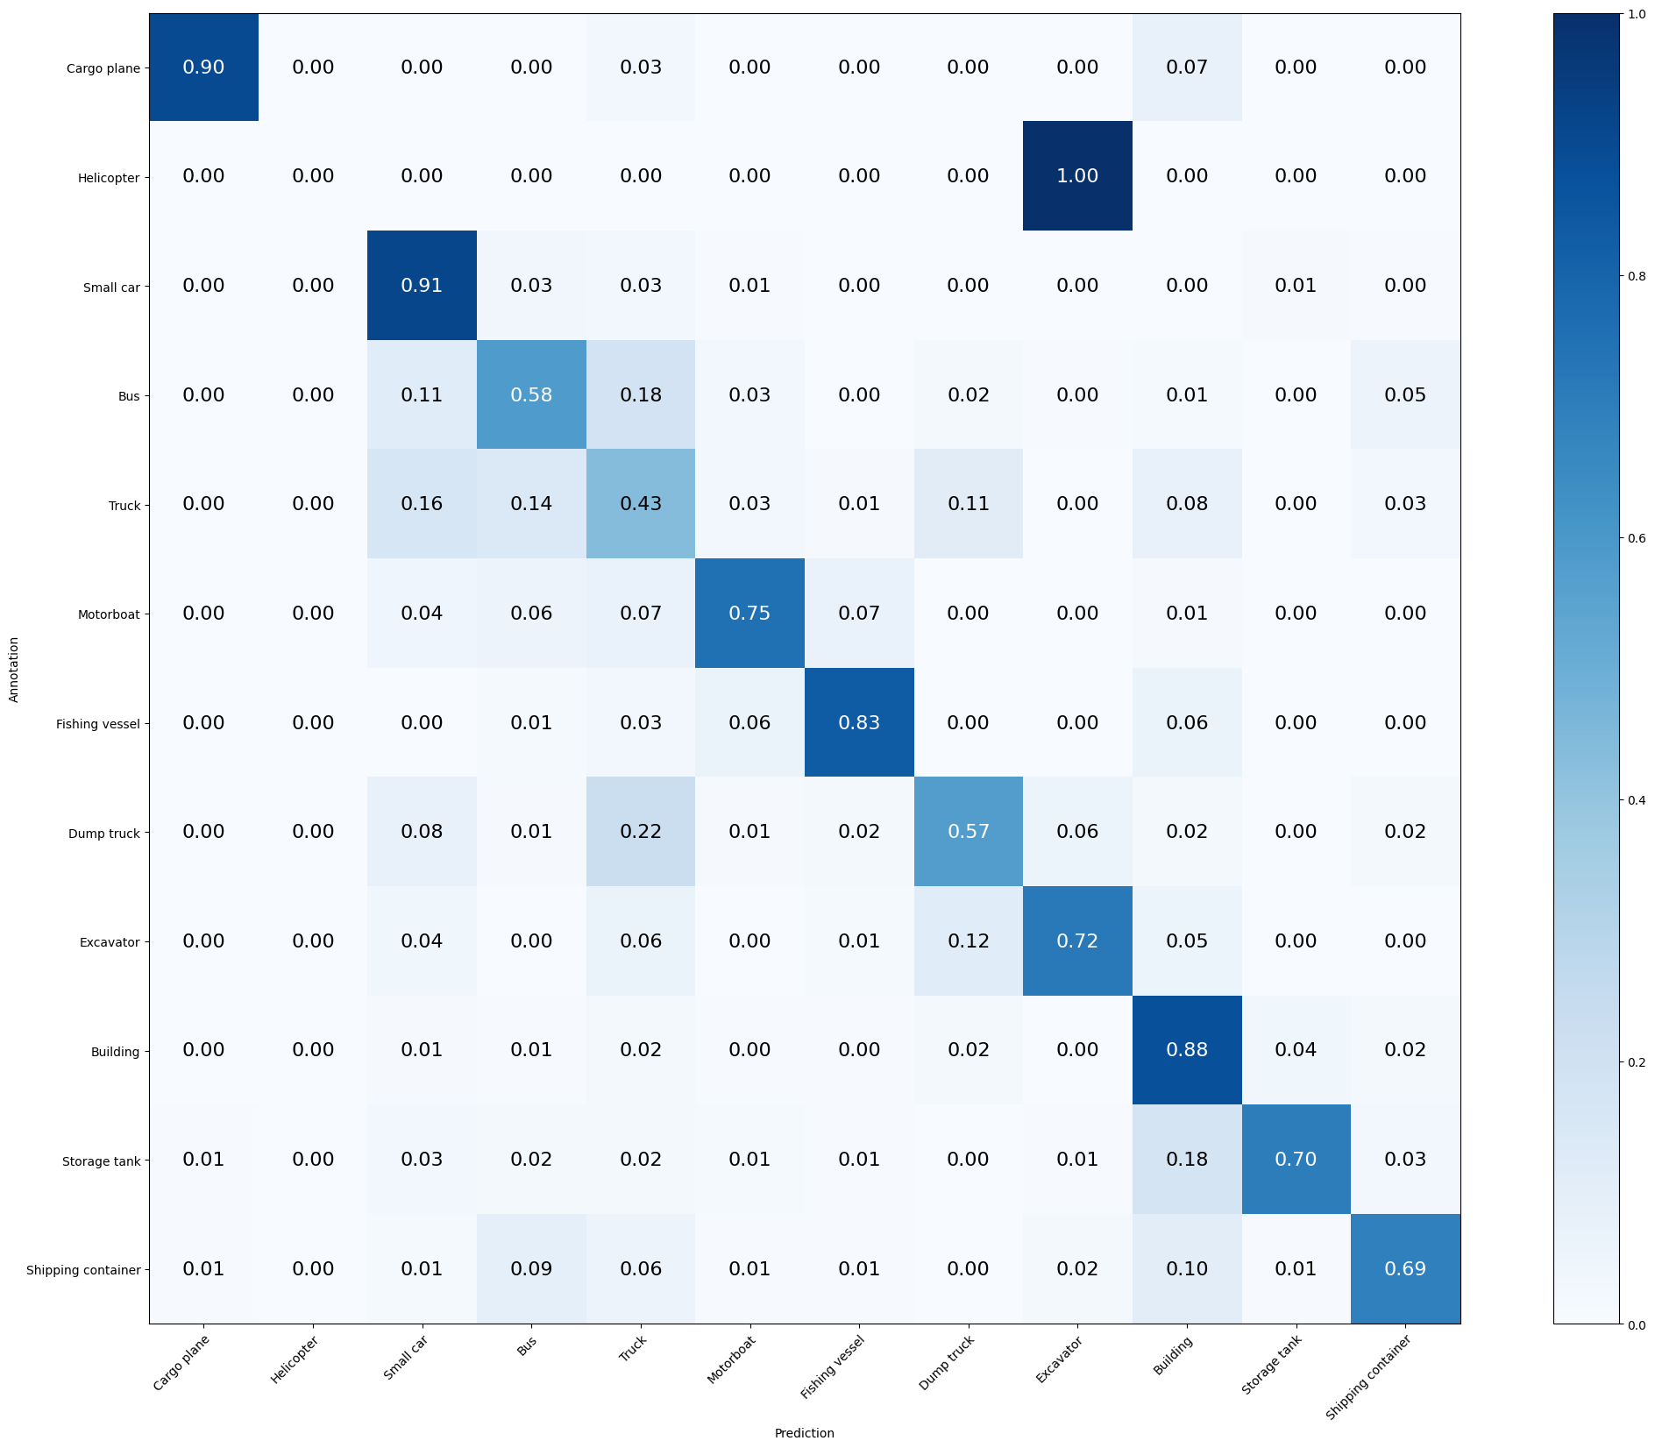

Mean Accuracy: 74.322%

Mean Recall: 66.389%

Mean Precision: 67.744%

> Cargo plane: Recall: 89.706% Precision: 96.825% Specificity: 99.903% Dice: 93.130%

> Helicopter: Recall: 0.000% Precision: 0.000% Specificity: 99.953% Dice: 0.000%

> Small car: Recall: 91.190% Precision: 80.126% Specificity: 94.470% Dice: 85.301%

> Bus: Recall: 58.447% Precision: 62.136% Specificity: 95.935% Dice: 60.235%

> Truck: Recall: 43.396% Precision: 50.000% Specificity: 93.860% Dice: 46.465%

> Motorboat: Recall: 75.281% Precision: 71.277% Specificity: 98.682% Dice: 73.224%

> Fishing vessel: Recall: 83.117% Precision: 80.000% Specificity: 99.224% Dice: 81.529%

> Dump truck: Recall: 57.265% Precision: 56.303% Specificity: 97.427% Dice: 56.780%

> Excavator: Recall: 71.795% Precision: 77.778% Specificity: 99.223% Dice: 74.667%

> Building: Recall: 87.702% Precision: 83.815% Specificity: 94.884% Dice: 85.714%

> Storage tank: Recall: 69.935% Precision: 81.061% Specificity: 98.741% Dice: 75.088%

> Shipping container: Recall: 68.831% Precision: 73.611% Specificity: 98.085% Dice: 71.141%

**MODEL 9: Four Convolutional layers** (*batch_size reduced to 32, kernel_size(3,3), GlobalAveragePooling2D*)

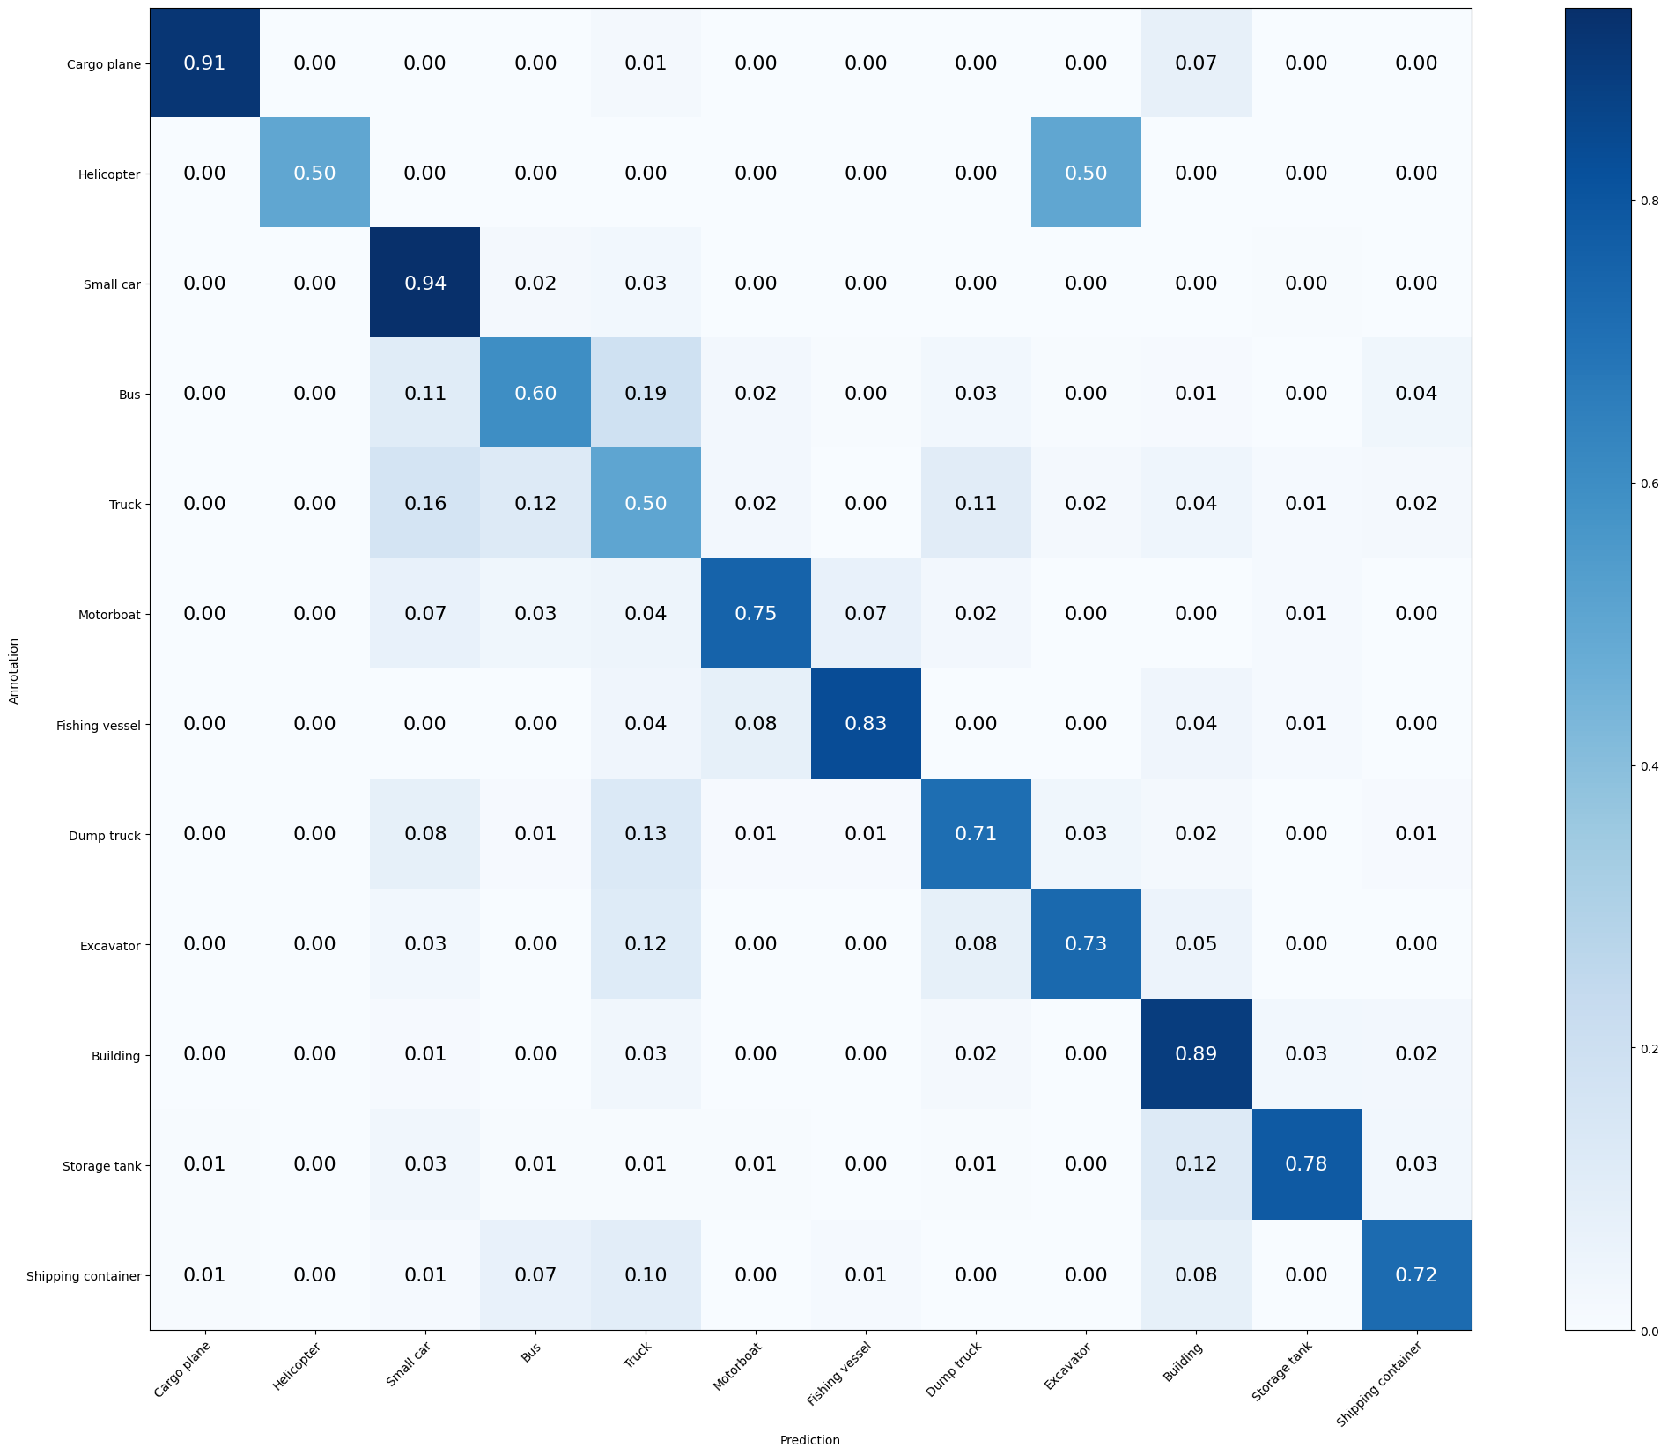

Mean Accuracy: 77.736%

Mean Recall: 73.866%

Mean Precision: 75.758%

> Cargo plane: Recall: 91.176% Precision: 95.385% Specificity: 99.855% Dice: 93.233%

> Helicopter: Recall: 50.000% Precision: 50.000% Specificity: 99.953% Dice: 50.000%

> Small car: Recall: 93.571% Precision: 80.533% Specificity: 94.470% Dice: 86.564%

> Bus: Recall: 59.817% Precision: 69.681% Specificity: 97.030% Dice: 64.373%

> Truck: Recall: 50.189% Precision: 53.414% Specificity: 93.807% Dice: 51.751%

> Motorboat: Recall: 75.281% Precision: 76.136% Specificity: 98.975% Dice: 75.706%

> Fishing vessel: Recall: 83.117% Precision: 85.333% Specificity: 99.466% Dice: 84.211%

> Dump truck: Recall: 70.940% Precision: 61.481% Specificity: 97.427% Dice: 65.873%

> Excavator: Recall: 73.077% Precision: 85.075% Specificity: 99.515% Dice: 78.621%

> Building: Recall: 88.710% Precision: 88.176% Specificity: 96.407% Dice: 88.442%

> Storage tank: Recall: 78.431% Precision: 85.714% Specificity: 98.992% Dice: 81.911%

> Shipping container: Recall: 72.078% Precision: 78.169% Specificity: 98.438% Dice: 75.000%

**MODEL 10: Four Convolutional layers** ( *LeakyReLU, SpatialDropout2D*)

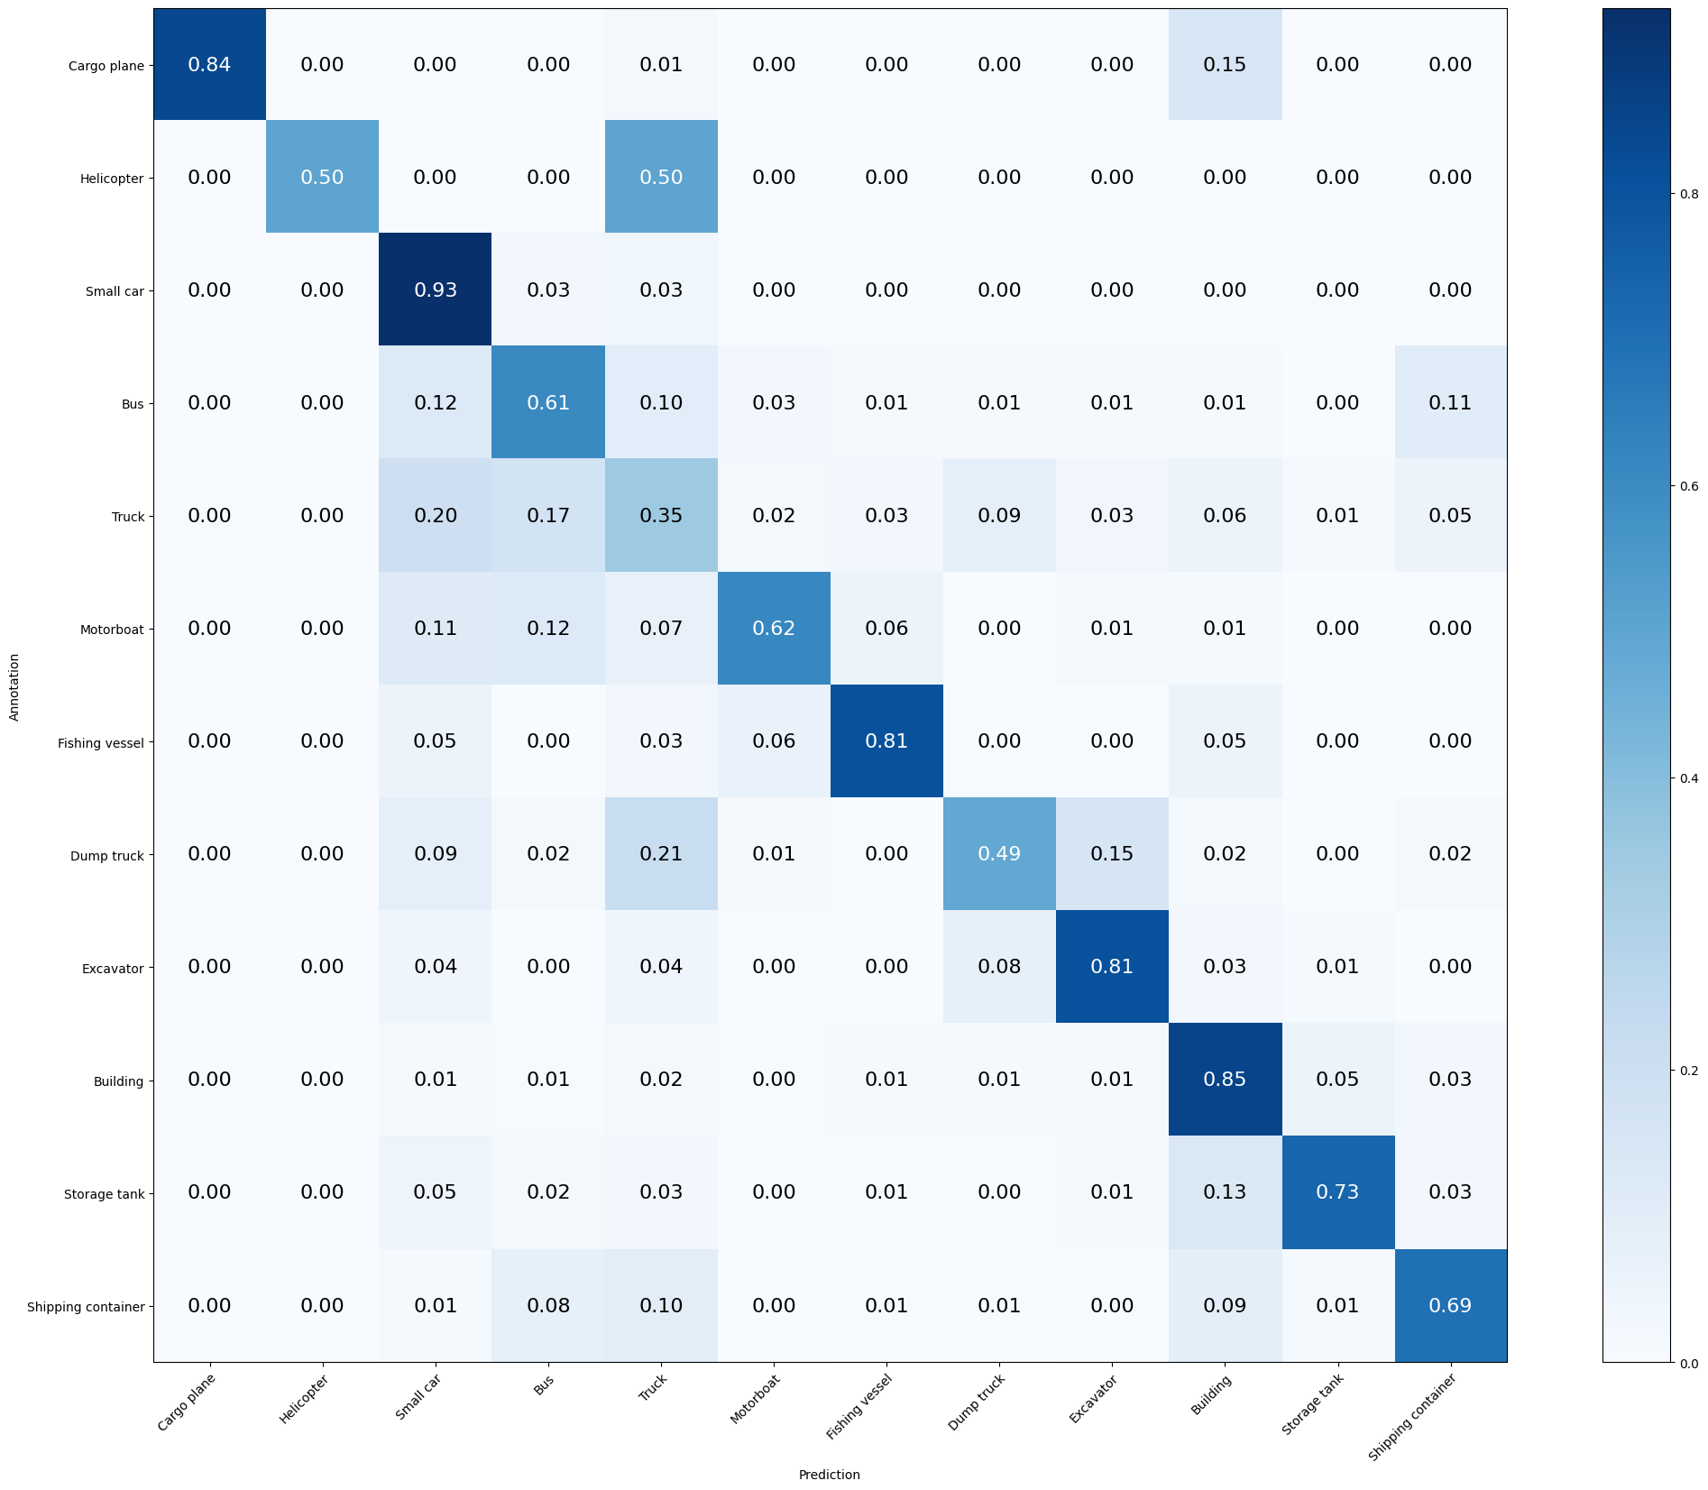

Mean Accuracy: 72.544%

Mean Recall: 68.472%

Mean Precision: 73.467%

> Cargo plane: Recall: 83.824% Precision: 96.610% Specificity: 99.903% Dice: 89.764%

> Helicopter: Recall: 50.000% Precision: 100.000% Specificity: 100.000% Dice: 66.667%

> Small car: Recall: 92.619% Precision: 76.424% Specificity: 93.015% Dice: 83.746%

> Bus: Recall: 60.731% Precision: 60.181% Specificity: 95.414% Dice: 60.455%

> Truck: Recall: 34.717% Precision: 47.179% Specificity: 94.501% Dice: 40.000%

> Motorboat: Recall: 61.798% Precision: 73.333% Specificity: 99.024% Dice: 67.073%

> Fishing vessel: Recall: 80.519% Precision: 74.699% Specificity: 98.981% Dice: 77.500%

> Dump truck: Recall: 48.718% Precision: 61.290% Specificity: 98.219% Dice: 54.286%

> Excavator: Recall: 80.769% Precision: 63.636% Specificity: 98.252% Dice: 71.186%

> Building: Recall: 85.282% Precision: 85.628% Specificity: 95.676% Dice: 85.455%

> Storage tank: Recall: 73.203% Precision: 77.778% Specificity: 98.388% Dice: 75.421%

> Shipping container: Recall: 69.481% Precision: 64.848% Specificity: 97.077% Dice: 67.085%

**MODEL 11: Four Convolutional layers** (*gradual kernel_size (1,1) - (3,3) - (3,3) - (5,5)*)

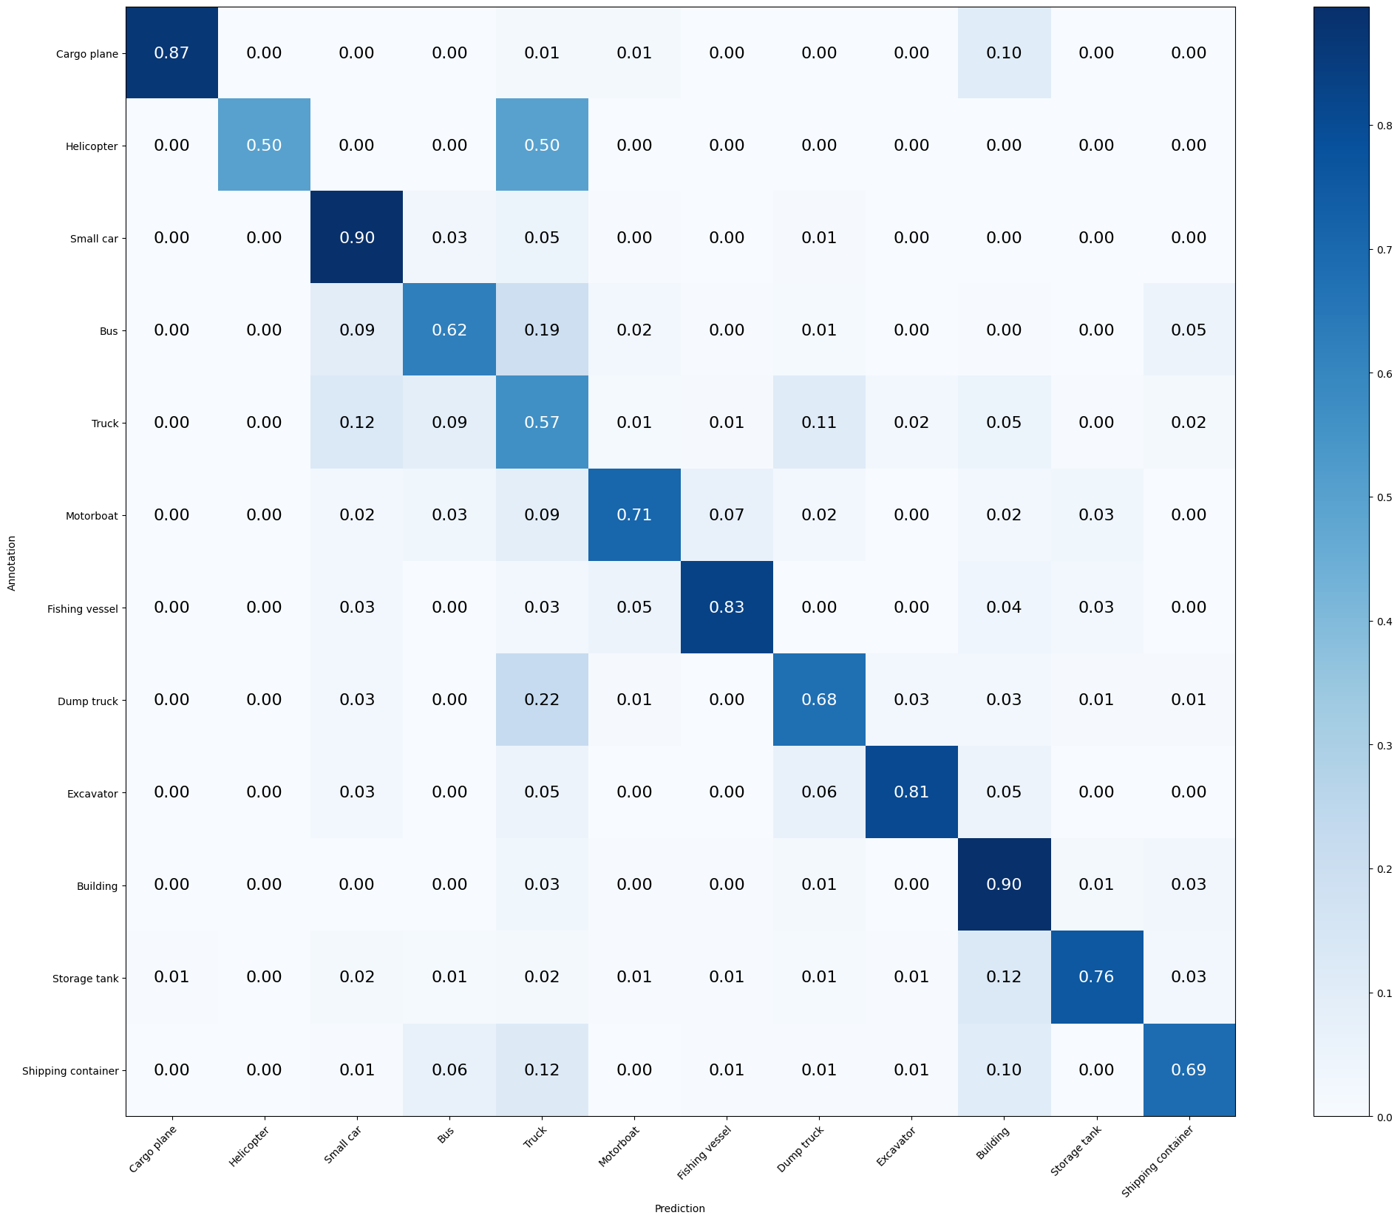

Mean Accuracy: 77.502%

Mean Recall: 73.446%

Mean Precision: 79.938%

> Cargo plane: Recall: 86.765% Precision: 96.721% Specificity: 99.903% Dice: 91.473%

> Helicopter: Recall: 50.000% Precision: 100.000% Specificity: 100.000% Dice: 66.667%

> Small car: Recall: 89.524% Precision: 84.876% Specificity: 96.100% Dice: 87.138%

> Bus: Recall: 62.100% Precision: 72.340% Specificity: 97.290% Dice: 66.830%

> Truck: Recall: 56.604% Precision: 51.020% Specificity: 92.312% Dice: 53.667%

> Motorboat: Recall: 70.787% Precision: 76.829% Specificity: 99.073% Dice: 73.684%

> Fishing vessel: Recall: 83.117% Precision: 83.117% Specificity: 99.369% Dice: 83.117%

> Dump truck: Recall: 67.521% Precision: 60.769% Specificity: 97.476% Dice: 63.968%

> Excavator: Recall: 80.769% Precision: 84.000% Specificity: 99.417% Dice: 82.353%

> Building: Recall: 89.516% Precision: 86.381% Specificity: 95.737% Dice: 87.921%

> Storage tank: Recall: 75.817% Precision: 88.550% Specificity: 99.244% Dice: 81.690%

> Shipping container: Recall: 68.831% Precision: 74.648% Specificity: 98.185% Dice: 71.622%

**MODEL 12: Six Layers** (*64*, *128*, *256*, *256*, *512*, *512*) **+ Data Augmentation** (rotation_range, width_shift_range, height_shift_range, zoom_range, …)

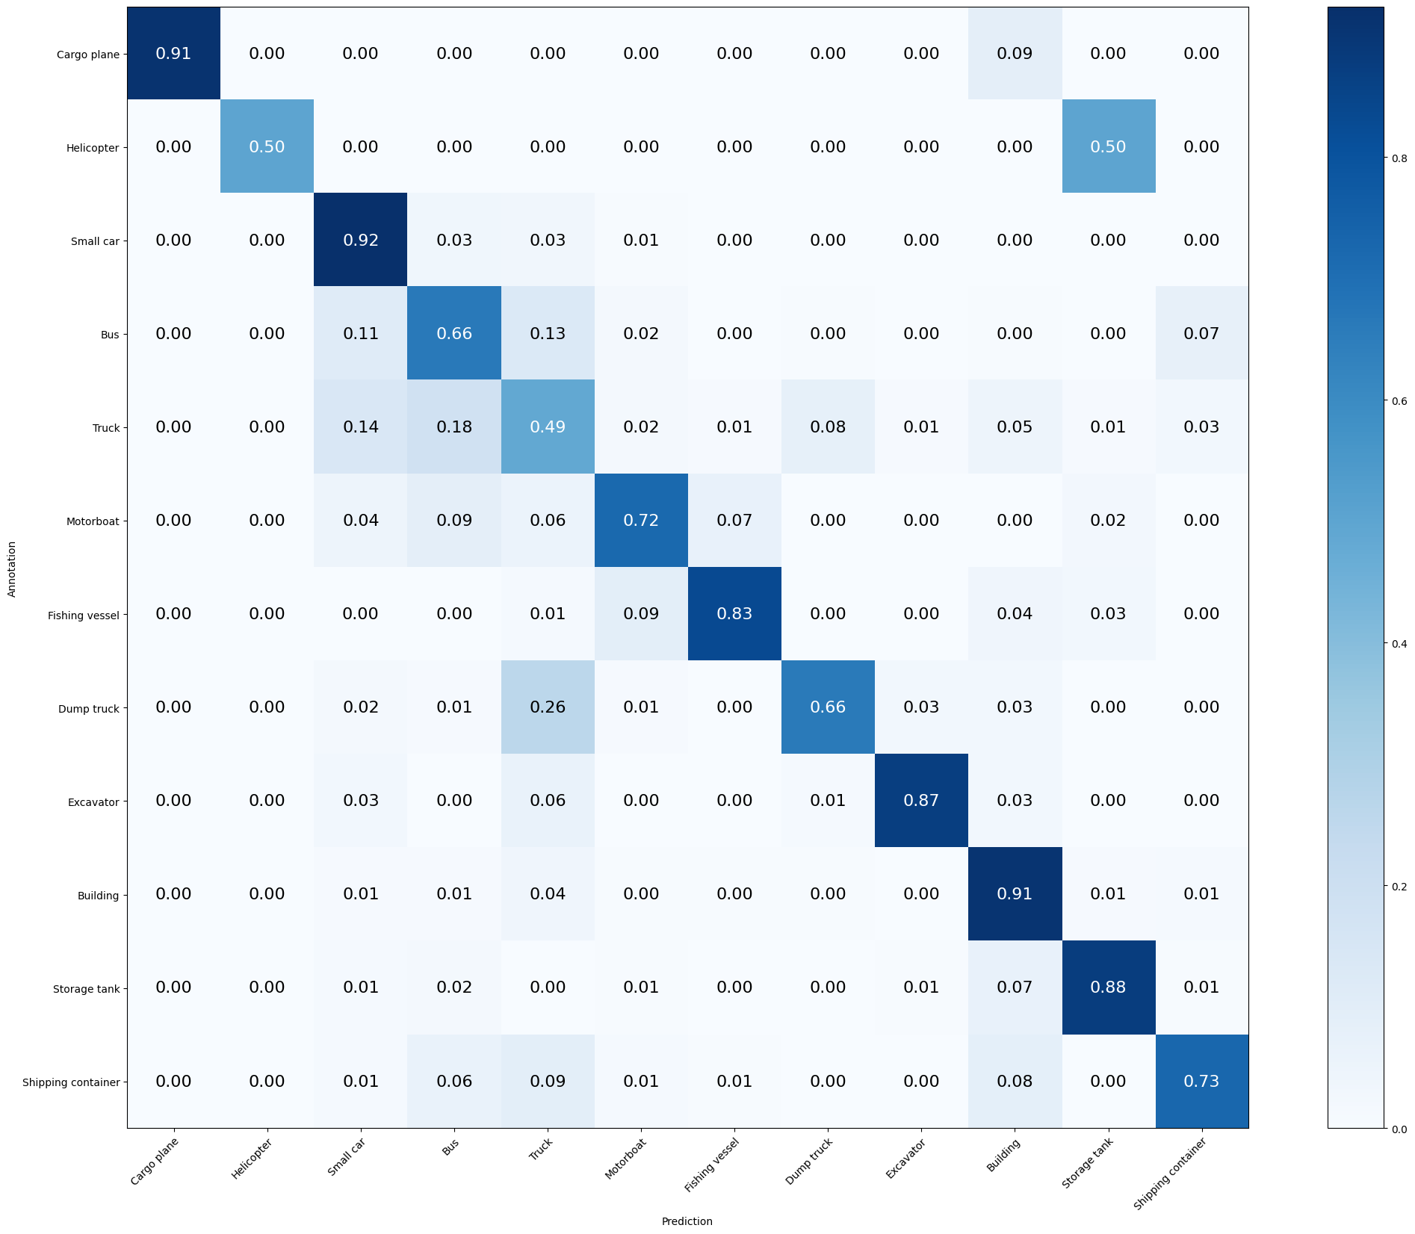

Mean Accuracy: 79.280%

Mean Recall: 75.642%

Mean Precision: 81.839%

> Cargo plane: Recall: 91.176% Precision: 100.000% Specificity: 100.000% Dice: 95.385%

> Helicopter: Recall: 50.000% Precision: 100.000% Specificity: 100.000% Dice: 66.667%

> Small car: Recall: 92.381% Precision: 83.441% Specificity: 95.518% Dice: 87.684%

> Bus: Recall: 66.210% Precision: 61.966% Specificity: 95.362% Dice: 64.018%

> Truck: Recall: 48.679% Precision: 52.869% Specificity: 93.860% Dice: 50.688%

> Motorboat: Recall: 71.910% Precision: 71.910% Specificity: 98.780% Dice: 71.910%

> Fishing vessel: Recall: 83.117% Precision: 85.333% Specificity: 99.466% Dice: 84.211%

> Dump truck: Recall: 65.812% Precision: 75.490% Specificity: 98.763% Dice: 70.320%

> Excavator: Recall: 87.179% Precision: 90.667% Specificity: 99.660% Dice: 88.889%

> Building: Recall: 90.927% Precision: 89.662% Specificity: 96.833% Dice: 90.290%

> Storage tank: Recall: 87.582% Precision: 92.414% Specificity: 99.446% Dice: 89.933%

> Shipping container: Recall: 72.727% Precision: 78.322% Specificity: 98.438% Dice: 75.421%